OTHER EVALUATIONS (*):
Members | Task Details
Member 1 | Task 1 (Work - 100%)
Member 2 | Task 1 (Work - 100%)
Member 3 | Task 1 (Work - 100%)

TASK ASSIGNMENT TABLE:
Content | Result
Average total time to complete the lab (1)
Video Link (2)
(if any)
Feedback (3) (if any)
+ Challenges
+ Suggestions …
Self-Assessment Score (4) | /10
(*): Sections (1) and (4) are mandatory.

Teacher: Phan Trung Phát
Group: TH1.01
Name | ID
Nguyễn Văn A | MSSV 1
Nguyễn Thị B | MSSV 2
Nguyễn Văn C | MSSV 3

NAME OF THE LAB
1

Question 1

Evidence:
Content.
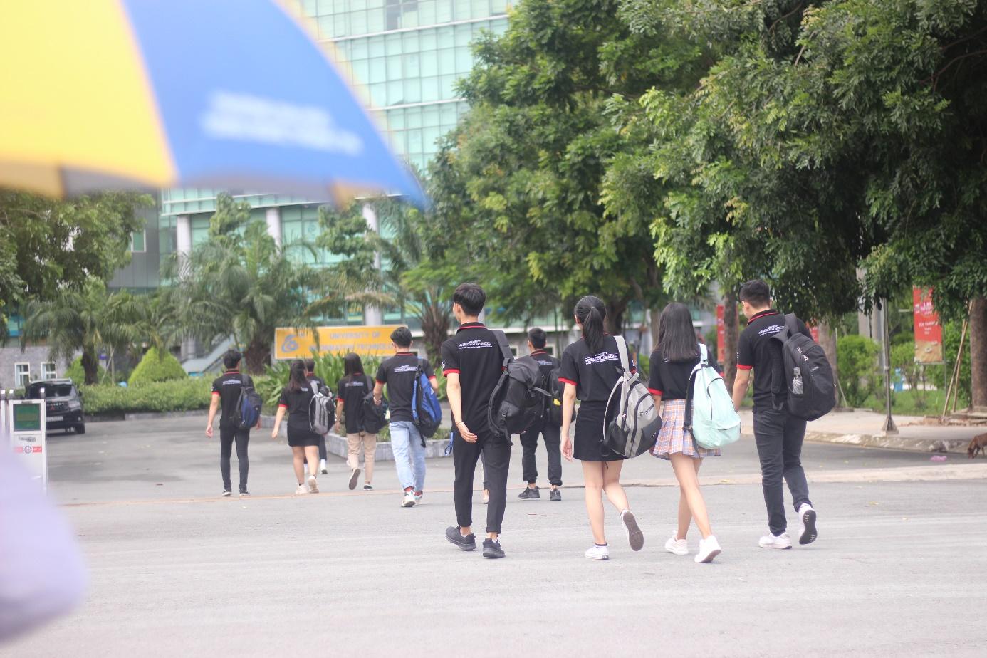
Figure 1. Illustrative Image

Explanation:
Content.

Question 2

Evidence:
Content.

Explanation:
Content.

Question 3

Evidence:
Content.

Explanation:
Content.

GENERAL REQUIREMENTS
- Evaluation
- Properly prepared all requirements stated in the lab.
- Students understand and can complete the lab independently, answering all required questions.
- Submitted a detailed report of the completed tasks, observations, and attached screenshots of results (if any); included explanations for observations (if any).
- Students presented their results and submitted the report.
- Report Format
- Submit a .docx file focusing on content and explanations.
- Use Cambria or Times New Roman font (however, the entire report must use a single consistent font) - font size 13. Align text as Justify. Center-align screenshots.
- File naming format: GroupCode-LabX_StudentID1_StudentID2 (where X is the lab session number).
Example: TH1.01-Lab1_25520001_25520002
- If the report contains multiple files, compress them into a .ZIP file using the same naming format.
- Reports that do not follow the correct naming format will NOT be graded.
- Submit the report according to the agreed deadline on courses.uit.edu.vn.
Late submissions, plagiarism, etc., will be handled
based on the severity of the violation.
END

